**Clinical Calculator Audit Tool**

**Version 0.1. Documentation**

**Made by Udit Sharma**

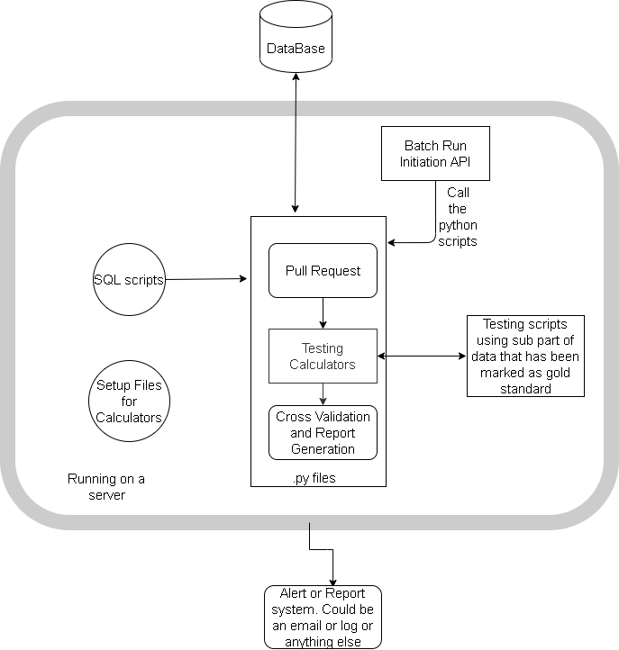

Fig 1. General Architecture for the Audit tool

1. **File Structure: -**

Fig 2. File structure for Clinical calculator audit tool

1. **Main**

The main function to control the process. It calls the fetch data file to get the data and passes it on to the validation file. It also receives the audit report back from the validation file and passes it on to the main controller for the auditing tool.

1. **Fetch Data**

Fetch data file is used to fetch the data from the data warehouse. It uses SQL scripts to pull the data.

1. Fetch data- The main function of this file to access all the functions
2. Query data- The function to runs the SQL scripts and pull the data
3. Create connection- The function to create connection with the data warehouse
4. Clean data – The function to clean the data so that it can be used for performing calculation
5. **SQL scripts**

The SQL scripts are the ‘.SQL’ files which contain the SQL queries and conditions to pull the data from the data warehouse.

1. **Calculator**

The calculator contains the logic that would be used for performing the calculation. It contains all the different calculation functions.

1. **Validation**

This file contains the validation function and the audit report generation function.

1. Validation – This is the main function of this file
2. Calculate ­– These functions are used to call the calculator functions and perform calculations
3. Validate functions – These functions are used for validation of the data by comparing results of audit tool and live calculator.
4. Add comments – This function is used to add comment to the audit report (will change it to add data to report or edit report once the template is finalized)
5. **Test**

This contains all the testing functions for testing the audit tool. It will draw data from the Test Data File(.csv). The advantage of this is that it would make the audit tool easier to be used by clinicians and developer alike as they can just add the data and check their results.

1. **Info/Markdown file**

General markdown file for the calculator.

1. **Test Data file (.csv)**

Test data file which can be used to test the audit tool or to perform calculations using audit tool.

1. **Audit Report Template**
2. Calculator name
3. Date of Calculation
4. Date of Audit
5. Calculation number/Unique id
6. Actual Calculation Result
7. Audit Calculation Result
8. Comments